**FOR IMMEDIATE RELEASE**

Media Contact: Casey Lynn, Public Relations Manager

631.232.0011 ext.457 or [clynn@ucp-li.org](mailto:clynn@ucp-li.org)

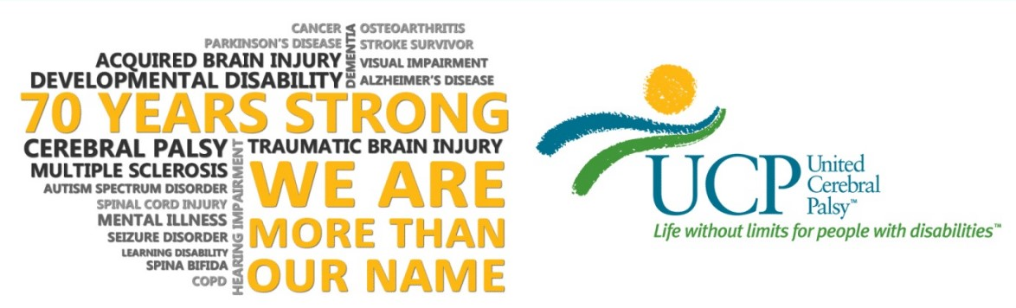

**Patricia Tutiven, Vice President & Senior Market Manager, at People’s United Bank Joins UCP of Long Island Board of Directors**

**Hauppauge, NY (December 11, 2019)** – The Board of Directors of United Cerebral Palsy (UCP) of Long Island is proud to announce that Patricia Tutiven, Vice President, and Senior Marketing Manager at People’s United Bank, has joined the Board of Directors.



“Patricia has been a dedicated supporter of UCP of Long Island and we have seen the unselfish inscription she has made on Long Island, both as a business leader and distinguished humanitarian. Patricia brings a fervor for facilitating others, especially children, to UCP and I look forward to teaming up with her to drive our charge for years to come”, said ***Thomas Pfundstein, Chair of the Board of Directors.***

Patricia Tutiven has more than 15 years of experience in the financial services industry. Tutiven has been with People’s United Bank since 2009 and is currently responsible for the overall management of six branches in Suffolk County, Long Island.  Prior to joining People’s United Bank, she was a VP of Sales and Marketing for American Community Bank. She holds an MBA in Business Administration from St. Joseph’s College. Tutiven currently sits on United Cerebral Palsy’s ***Life Without Limits*** Gala and Handbag Bingo Committees and is a very valuable contributor to both of these events.

Tutiven’ s fundamental concentration is developing, implementing and managing Branch sales plans and processes to achieve goals, while assigning individual sales goals. She monitors the progress towards the achievement of these goals and provides direction and coaching to Financial Services Staff concerning pro-active sales techniques and activities, timing of campaigns and measurement of results.

“I am very much honored to join the UCP of Long Island Board of Directors. Being able to impact someone’s life in such a supportive way is a blessing, and I feel very thankful for the chance”, said Tutiven.

###

*For over 70 years, United Cerebral Palsy of Long Island has positively impacted the lives of people with disabilities through the outstanding quality of our programs and services and the compassion we convey to those we serve. UCP of Long Island is committed to advancing the independence, productivity and full citizenship of people with disabilities by creating* ***Life Without Limits****. Our heartfelt mission is to provide life skills training, education, advocacy, meaningful employment and a place to call home for Long Islanders with a wide range of disabilities. UCP of Long Island proudly upholds the values of excellence, integrity, dignity, empowerment, responsibility, accountability, vision and innovation. For information on UCP of Long Island programs and services, please visit www.ucp-li.org*.