FOR IMMEDIATE RELEASE
Media Contact: Casey Lynn, Public Relations Manager
631.232.0011 ext.457 or clynn@ucp-li.org
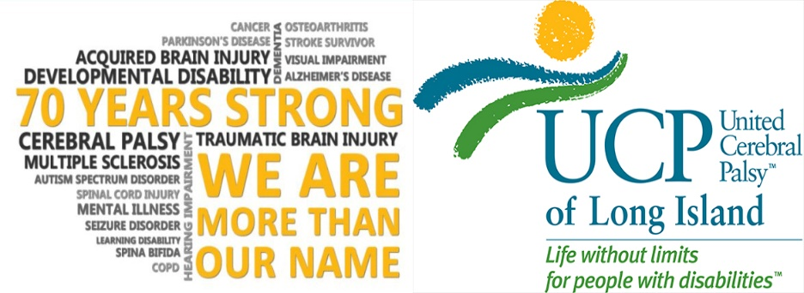

UCP of Long Island Teams Up With The Patchogue Theatre For Artist Appreciation Event
Patchogue, NY (February 3, 2020) –United Cerebral Palsy (UCP) of Long Island is proud to announce a partnership with The Patchogue Theatre highlighting the Inaugural Art Appreciation Event to be held the month of February at the theatre located at 71 East Main Street, Patchogue, NY.
“I am extremely excited to be teaming up with The Patchogue Theatre and the Patchogue community to promote UCP of Long Island’s amazing and inspirational artistry, hand-crafted and painted by our incredible individuals,” said Judith McCowan, President and CEO of UCP of Long Island.
For the entire month of February, paintings created by UCP-LI’s Individuals in the Adult Day Art Program will be available for viewing to the public at the historic Patchogue Theatre, right in the heart of The Patchogue Village.
The Patchogue Theatre, a non-profit organization that enriches, educates, and entertains a diverse audience by cultivating and showcasing a broad variety of performing artists has been open for business since December of 1998.
“It is an honor to join UCP of Long Island as a community partner to showcase the outstanding artistry work from their talented individuals,” said Gary Hygom, Executive Director of The Patchogue Theatre.
The Patchogue Theatre will feature a total of 19 artists in the exhibit with 36 pieces of work to be viewed outside their famous auditorium.
To highpoint the month long event, on Wednesday, February 26, The Patchogue Theatre, in conjunction with UCP of Long Island, will host a special night highlighting the exhibit and our talented artists.
Attendees will be shown the uniqueness of the paintings created by individuals with disabilities in UCP-LI’s Adult Art Program. This program was introduced to help them strengthen their fine motor-skills, relieve tightness caused by Cerebral Palsy, Arthritis & other conditions.
With every stroke of the brush, UCP-LI’s artists demonstrate their skills. Each artist embraces his or her unique talent, using adaptive tools when needed & exploring unconventional techniques such as painting with bubble wrap, chopsticks, Brillo, chicken wire, among others.

The end result is always something beautiful & special. The arts build relationships and “open doors” as UCP-LI’s artists participate in events throughout the Long Island community where they can sell their work & showcase their many abilities.

UCP of Long Island provides residential care in 31 homes across Suffolk County, serving two residential homes in the town of Patchogue.
###
For over 70 years, United Cerebral Palsy of Long Island has positively impacted the lives of people with disabilities through the outstanding quality of our programs and services and the compassion we convey to those we serve. UCP of Long Island is committed to advancing the independence, productivity and full citizenship of people with disabilities by creating Life Without Limits. Our heartfelt mission is to provide life skills training, education, advocacy, meaningful employment and a place to call home for Long Islanders with a wide range of disabilities. UCP of Long Island proudly upholds the values of excellence, integrity, dignity, empowerment, responsibility, accountability, vision and innovation. For information on UCP of Long Island programs and services, please visit www.ucp-li.org.

